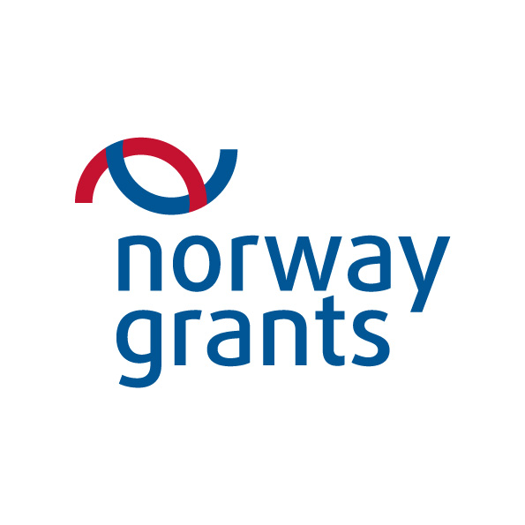
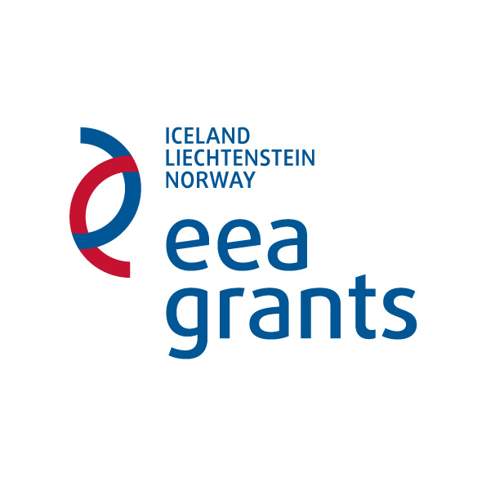


PROJECT PROGRESS REPORT (PPR)

This report is to be submitted to the Programme Operator not later than a month following the end of the period being reported

Report Number | PPR/[insert project number]/[Insert sequential number of PPR]/20XX

A. PROJECT DETAILS
Project no.
Project title
Grant | Norway
Programme Area
Date of Project Contract
Project Promoter
Project Leader
Reporting period | 01 December – 31 May 01 June – 30 November
Total Public Eligible Amount | €
Start / End date of the project | DD | MM | YY | to | DD | MM | YY
Start / End date of the project | (as stated in the Project Contract/Addendum) (delete as applicable )

A.1 Addenda to the Project Contract |  | Tick here if section is Not Applicable to project
Number of Addenda | Date of Signature  dd/mm/yyyy | Reason
1
2
3
4
Add rows if required]

B. Incurred / Actual Expenditure (processed through CARS)
 | Contracted | Previously incurred expenditure | Expenditure incurred this period | Total to date
Eligible expenditure
Non-eligible expenditure
Total Expenditure

C. Indicators
Indicator (Expected Outcomes and Outputs) | Target value | Achievement/s to date | Progress to date towards achieving indicator

[Add further rows if required]

D. HORIZONTAL ISSUES
Issue | How have these issues (where applicable) been addressed by the Project in this reporting period?

Sustainable development - environmental

Sustainable development - economic

Sustainable development - social

Gender equality

Good Governance

Bilateral Relations - Iceland

Bilateral Relations - Liechtenstein

Bilateral Relations - Norway

Additional comments

E. INFORMATION AND PUBLICITY MEASURES (carried out DURING THIS REPORTING PERIOD)
Type of Media | Description | Eligible Value (excluding VAT) | Visual ID used (Y / N) | Quantity  (designed) | Frequency of appearance / distribution  (use whole numbers only, e.g. 5) | Period of appearance / distribution
 |  |  |  |  |  | From |  | To
Print Media
 | Description | Eligible Value (excluding VAT) | Visual ID used (Y / N) | Quantity  (produced) | Frequency of airing  (use whole numbers only, e.g. 5) | Period of airing
 |  |  |  |  |  | From |  | To
Audio-Visual Mass Media
 | Description | Eligible Value (excluding VAT) | Visual ID used (Y / N) | Quantity  (produced) | Total distributed  (use whole numbers only, e.g. 5) | Period of distribution
 |  |  |  |  |  | From |  | To
Promotional Material (e.g. CDs, DVDs, bags, pencils, mugs, etc)
 | Description | Eligible Value (excluding VAT) | Visual ID used (Y / N) | Quantity  (set up) | Total hits / likes / subscribers  (use whole numbers only, e.g. 5) | Period of presence
 |  |  |  |  |  | From |  | To
Online Presence | Dedicated project webpage  (Compulsory for projects over €50,000)
Online Presence | Dedicated project website
Online Presence | Page / Group on Social Network
 | Description | Eligible Value (excluding VAT) | Visual ID used (Y / N) | Quantity  (designed) | Total number of locations  (use whole numbers only, e.g. 5) | Period of appearance
 |  |  |  |  |  | From |  | To
Signage | Billboard
Signage | Plaque
Signage | Stickers
Signage | Poster
Signage | Other
 | Name of Event | Eligible Value (excluding VAT) | Visual ID used (Y / N) | Number of attendees | Brief description of event | Date of event
 |  |  |  |  |  | (From) | (To)
Information Activities | Launch Event  (Compulsory)
Information Activities | Second Event (Closing)  (Compulsory)
Information Activities | Third Event  (Compulsory for projects over  €500,000)

F. IRREGULARITIES
a. Have there been any irregularity/irregularities detected according to National rules and Programme Regulation during the reporting period covered by this report? |  | Yes |  | No
b. If yes, kindly fill in the following table:
Report Number | Date of Report |  | Irregularity Detected

G. PROBLEMS ENCOUNTERED AND PERCEIVED RISKS (carried out during this reporting period)
Please specify any problems encountered and how these were tackled/are being tackled.
 |  |  | Issue | Reason/s | Actions to be taken | Responsibility for follow up | By when issue should be resolved (date/year)
Technical problems/Risks | Yes
Technical problems/Risks | No
Financial Problems/Risks | Yes
Financial Problems/Risks | No
Legal  Problems/Risks | Yes
Legal  Problems/Risks | No
Capacity Problems/Risks | Yes
Capacity Problems/Risks | No
Problems/Risks with Public Procurement | Yes
Problems/Risks with Public Procurement | No
Problems/Risks with MEPA Permits | Yes
Problems/Risks with MEPA Permits | No
Others  (Please Specify) | Yes
Others  (Please Specify) | No

H. FINAL REMARKS

I. ENDORSEMENT

Project Leader

Name in Block Letters | Signature
Designation | Date

Director (Programme Implementation) or Designate by delegated authority

Name in Block Letters | Signature
Designation | Date

List the indicators (both outcome and output) as indicated in the Project Description annexed to the Contract.
Please provide detailed yet concise (e.g. point form) information.
Eligible value comprises of Norway Grants share (85%) + Malta co-financing share (15%).
Visual ID means the logo of the Norway Grants, the flag of Malta and the co-financing statement.
The number of times the publicity measure appeared on the chosen medium.

